Use Case Document
Common Mapping and Transformation Service

Owner: caAdapter Development Team
National Cancer Institute
Center for Biomedical Informatics and Information Technology
2115 East Jefferson Street
Rockville, MD 20852

 |   Center for Biomedical Informatics and Information Technology


DOCUMENT REVISION HISTORY
Version Number | Date | Description
1.0 | 31-Aug-09 | - Initial Draft
2.0 | 18-Aug-10 | - Expand to common mapping and transformation
3.0 | 01-June-11 | - Expand scope to support XSLT

Background/Summary
This document contains the use cases for the caAdapter Common Mapping and Transformation Service model. This module will provide the following capabilities:
- Model and represent XSD as metadata of source or target data
- Implement XML data parser conform with XSD
- Map source metadata (XSD) to target metadata (XSD)
- Implement data processing functions
- Generate artifacts for XSLT compatible data transformation tools
- Generate artifacts for XQuery compatible data transformation tools
- Produce XML instances conformed to XSD specification
- Provide APIs for programming integration and service integration
Table of Content
Background/Summary 3
1 Introduction 7
1.1 Overview 7
1.2 Related Documents 7
2 Actors and Goals 7
2.1 Systems Analyst 8
2.2 Application Developer 8
2.3 External System 8
3 Use Cases 8
3.1 Present Metadata of Source Data in the Mapping Source Panel 8
3.1.1 Use Case Model 8
3.1.2 Brief Description 8
3.1.3 Primary Actor 9
3.1.4 Preconditions 9
3.1.5 Basic Flow of Events 9
3.1.6 Alternative Flow 9
3.1.7 Post Conditions 9
3.1.8 Special Requirements 9
3.2 Present Metadata of Target Data in the Mapping Target Panel 10
3.2.1 Use Case Model 10
3.2.2 Brief Description 10
3.2.3 Primary Actor 10
3.2.4 Preconditions 10
3.2.5 Basic Flow of Events 10
3.2.6 Alternate Flow 10
3.2.7 Post Conditions 11
3.2.8 Special Requirements 11
3.3 Map Source Metadata to Target Metadata 12
3.3.1 Use Case Model 12
3.3.2 Brief Description 12
3.3.3 Primary Actor 12
3.3.4 Preconditions 12
3.3.5 Basic Flow of Events 12
3.3.6 Alternate Flow 13
3.3.7 Post Conditions 13
3.3.8 Special Requirements 13
3.4 Generate Integration Artifacts for Compatible Transformation Tools 14
3.4.1 Use Case Model 14
3.4.2 Brief Description 14
3.4.3 Primary Actor 14
3.4.4 Secondary Actor 14
3.4.5 Preconditions 14
3.4.6 Basic Flow of Events 14
3.4.7 Alternate Flow 15
3.4.8 Post Conditions 15
3.4.9 Special Requirements 15
3.5 Transform Source Dataset to Target Dataset 15
3.5.1 Use Case Model 16
3.5.2 Brief Description 16
3.5.3 Primary Actor 16
3.5.4 Secondary Actor 16
3.5.5 Preconditions 16
3.5.6 Basic Flow of Events 17
3.5.7 Alternate Flow 17
3.5.8 Post Conditions 17
3.5.9 Special Requirements 17
3.6 Transform Source Dataset to Target Dataset with Programming API 18
3.6.1 Use Case Model 18
3.6.2 Brief Description 18
3.6.3 Primary Actor 18
3.6.4 Secondary Actor 18
3.6.5 Preconditions 18
3.6.6 Basic Flow of Events 19
3.6.7 Alternate Flow 19
3.6.8 Post Conditions 19
3.6.9 Special Requirements 19
3.7 Use Integration Artifacts for Compatible Transformation Tools 20
3.7.1 Use Case Model 20
3.7.2 Brief Description 20
3.7.3 Primary Actor 20
3.7.4 Secondary Actor 20
3.7.5 Preconditions 20
3.7.6 Basic Flow of Events 21
3.7.7 Alternate Flow 21
3.7.8 Post Conditions 21
3.7.9 Special Requirements 21
3.8 Connect and Browse caDSR 22
3.8.1 Use Case Model 22
3.8.2 Brief Description 22
3.8.3 Primary Actor 22
3.8.4 Secondary Actor 22
3.8.5 Preconditions 22
3.8.6 Basic Flow of Events 22
3.8.7 Alternate Flow 23
3.8.8 Post Conditions 23
3.8.9 Special Requirements 23
3.9 Access through Web Browser 24
3.9.1 Use Case Model 24
3.9.2 Brief Description 24
3.9.3 Primary Actor 24
3.9.4 Secondary Actor 24
3.9.5 Preconditions 24
3.9.6 Basic Flow of Events 24
3.9.7 Alternate Flow 25
3.9.8 Post Conditions 25
3.9.9 Special Requirements 25
4 Overall Requirements 26
5 Requirements Prioritization 26
6 Sign Off 27
6.1 Approval 27

Introduction

Overview
The National Cancer Institute Center for Biomedical Informatics and Information Technology (NCI CBIIT) developed caAdapter tool with the goal of creating standards-based infrastructure components to facilitate medical research data exchange. caAdapter is a open source tool kit including Model Mapping Service, HL7 Mapping and Transformation Service, and Global Model Exchange Service. Users in the caBIG community need an easy-to-use tool to map and transform data from one dataset to another. This Common Mapping and Transformation Service (CMTS) is to support data mapping and transformation among different kinds of data sources.

The CMTS will be developed on the basis of XML schema (XSD) specification. It defines metadata of source data format and target data format with XSD including structure, content and semantic representation of Common Data Element (CDE). Mapping engine creates links between nodes of source XSD and target XSD. XQuery generator produces integration artifacts for XQuery compatible data transformation tools. XSLT generator produces integration artifacts for XSLT compatible data transformation tools. Transformation engine converts source data into target data using map between source data metadata and target data metadata.
This Use Case Document captures the main use cases of CMTS module. This module will extend caAdapter’s data mapping and transformation capabilities for data exchange.
The effort for developing this module will leverage existing caAdapter capabilities, and applicable open source packages.

Related Documents
- Common Mapping and Transformation Service Scope Document

Actors and Goals
An actor is a person, organization, or external system that plays a role in one or more interaction with the Common Mapping and Transformation Service module. The following is a list of Actors that interact with this module:

Systems Analyst
This actor will use the CMTS module to map source data metadata with target data metadata. The user also is able to invoke transformation engine to convert a source dataset into target dataset using predefined mapping.

Application Developer
This actor is responsible for developing data processing system using the transformation capabilities of the CTMS module. The system may integrate with CMTS transformation engine through programming API to use it as a plug-in unit. It can also access CMTS transformation engine through web service API to use it as a service provider.

External System
This actor represents any External System that interacts with the CMTS module using programming API or web service API.

Use Cases

Present Metadata of Source Data in the Mapping Source Panel

Use Case Model
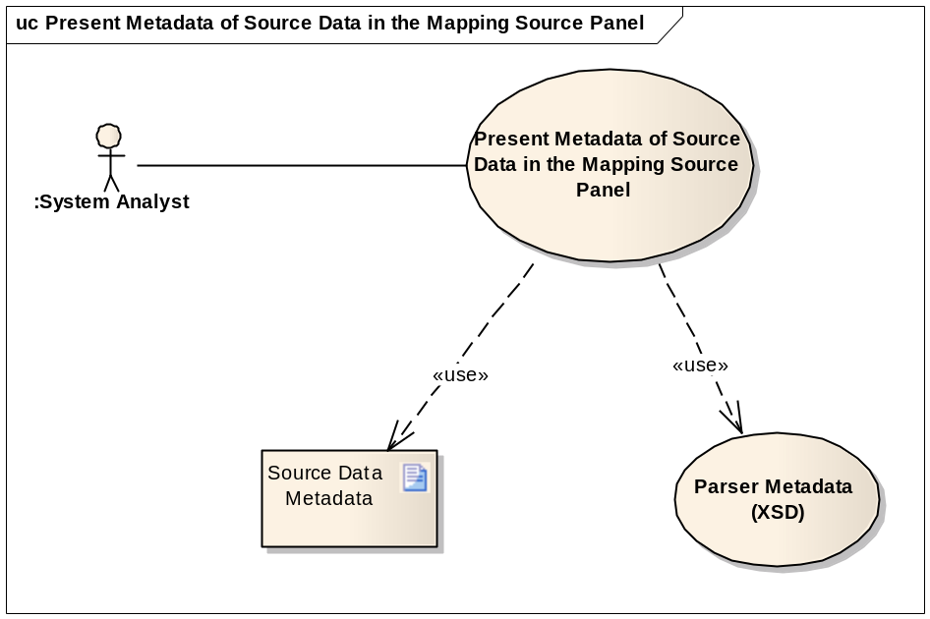

Brief Description
This use case covers reading the metadata of source data, and displaying it in the source panel of the mapping tool. The metadata is defined with XSD.

Primary Actor
Systems Analyst

Preconditions
- Metadata of source data is ready in the format of XSD

Basic Flow of Events
- User launches the CMTS module UI
- User selects a metadata file from the file system
- System automatically recognizes the type of the data structure represented in the metadata file identified by the Analyst
- The system validates the selected metadata file (Optional step).
- The system displays the metadata in a tree structure in the mapping source panel.

Alternative Flow
N/A

Post Conditions
Success Condition
- The system displays the metadata of source data the mapping source panel
Error Condition
- The system cannot recognize the metadata file. The system will display an error describing the issue, and provides the Analyst with possible solution(s).

Special Requirements
N/A

Present Metadata of Target Data in the Mapping Target Panel

Use Case Model
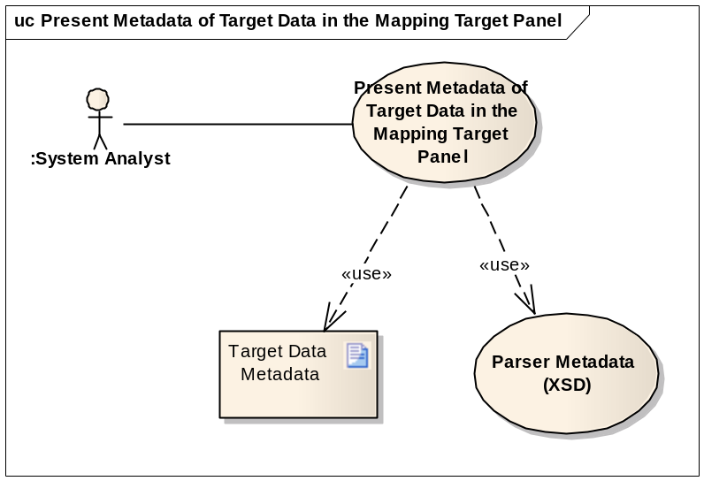

Brief Description
This use case covers reading the metadata of target data, and displaying it in the target panel of the mapping tool. The metadata is defined with XSD.

Primary Actor
Systems Analyst

Preconditions
- Metadata of target data is ready in the format of XSD

Basic Flow of Events
- User launches the CMTS module UI
- User selects a metadata file from the file system
- The system automatically recognizes the type of the data structure represented in the metadata file identified by the Analyst
- The system validates the selected metadata file (Optional step).
- The system displays the metadata in a tree structure in the mapping target panel

Alternate Flow
N/A

Post Conditions
Success Condition
- The system displays the metadata of target data in the mapping target panel
Error Condition
- The system is unable to recognize the metadata file. The system will display an error describing the issue, and providing the Analyst with possible solution(s)

Special Requirements
N/A

Map Source Metadata to Target Metadata

Use Case Model
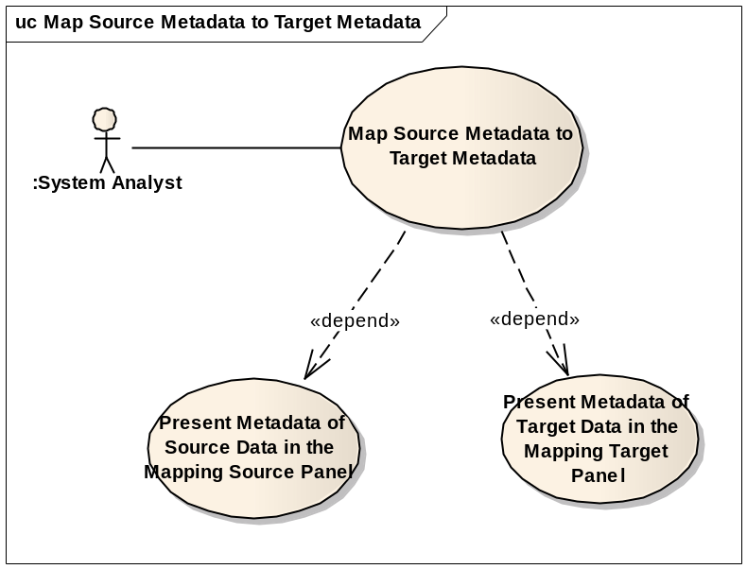

Brief Description
This use case covers the mapping activities from the source metadata to the target metadata. It creates mapping for data transformation engine to convert source data into target data and for code generation engine to generate integration artifacts of XQuery and XSLT.
This use case depends on success of two other use cases: Present Metadata of Source Data in the Mapping Source Panel; Present Metadata of Target Data in the Mapping Target Panel.

Primary Actor
Systems Analyst

Preconditions
- Source metadata is ready in the format of XSD.
- Target metadata is ready in the format of XSD.

Basic Flow of Events
            - User launches the CMTS module UI
            - User selects and open source metadata (XSD)
            - System presents source metadata on mapping source panel
            - User selects and open target metadata (XSD)
            - System presents target metadata on mapping target panel
            - User selects a source metadata node by clicking on it and dragging it over a target metadata node
            - System validates the mapping from source node to target node
            - User maps one or many source metadata node(s) to the input port(s) of data processing function(s); then maps the output port to a target metadata node. The functions will be used during data transformation
            - User deletes mapping links. System provides confirmation before executes a delete operation
            - Use saves the mapping into a file

Alternate Flow
  - User opens a mapping file saved earlier
  - The next steps in this flow are identical to steps 6 through 10 above

Post Conditions
Mapping file is saved for future use
Success Conditions
- Mappings are validated correctly according to identified validation rules
- A saved mapping file could be updated by user at a later time
Error Conditions
- System fails to create a mapping link and generates an error message explaining the problem, and advising user of possible solutions.
- System fails to open a saved mapping file because:
  - The source metadata file was modified since the last time the mapping file was saved
  - The target metadata file was modified since the last time the mapping file was saved

Special Requirements
The map file must be a text file to support system compatibility.

Generate Integration Artifacts for Compatible Transformation Tools

Use Case Model
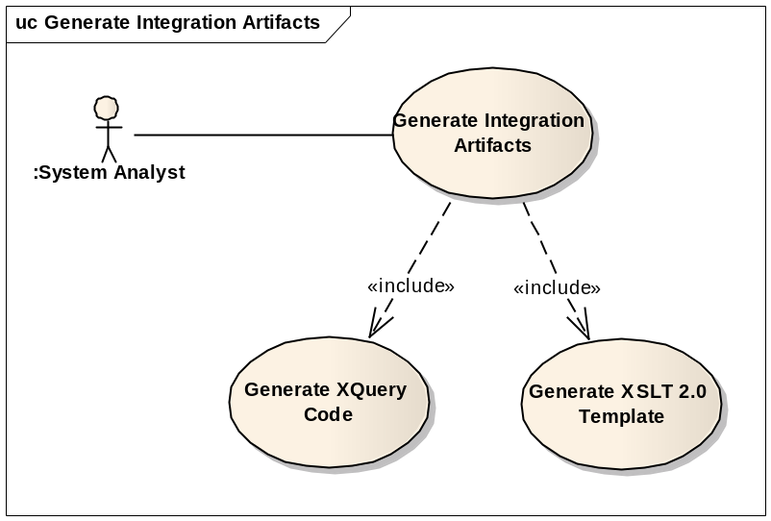

Brief Description
This use case covers generating integration artifacts for other compatible data transformation tools.
This use case uses two child use cases: Generate XQuery Code and Generate XSLT template.

Primary Actor
System Analyst

Secondary Actor
N/A

Preconditions
User has completed mapping which is saved as a file or run in system cache, along with source metadata and target metadata files

Basic Flow of Events
- User creates completed mapping using source metadata and target metadata. The mapping may or may not use data processing functions.
- User validates mapping against predefined mapping rules.
- User selects “Generate Integration Artifacts” action.
- User chooses type of integration artifacts: XQuery or XSLT.
- System promotes users to locate destination of the generated integration artifact.
- User sets file name for the generated artifact and launch “Generate” action.
- If the developer does not have an account on the Portal, She or he must be able to use the Portal to obtain one immediately by registering
- System generates and saves the integration artifact (XQuery or XSLT) into a separated file.

Alternate Flow
- User may select an existing mapping file at step 1.
- User proceeds step 2 to 8.

Post Conditions
Success Conditions
- Integration artifact is successfully generated and saved.
Error Conditions
- Fail to validate a mapping
- Fail to generate integration artifact.

Special Requirements
N/A

Transform Source Dataset to Target Dataset

Use Case Model
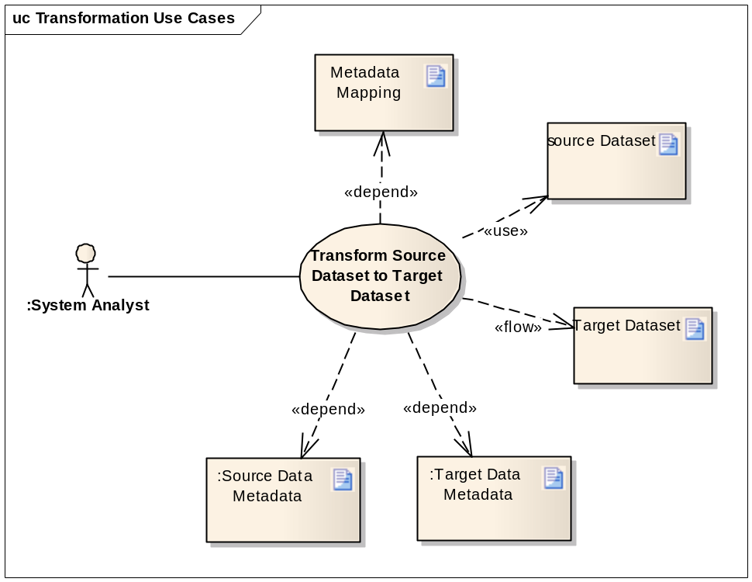

Brief Description
This use case covers the activities involved in transforming source dataset to target dataset using the predefined mapping along with associated source metadata and target metadata.

Primary Actor
Systems Analyst

Secondary Actor
N/A

Preconditions
- Mapping between the source metadata and target metadata has been completed
- A valid mapping file was created

Basic Flow of Events
- User selects opens a mapping file using CMTS UI, then selects the data transformation option
- System promotes user to specify source dataset(s) file, and name and location of target dataset file
- System process mapping file along with the associated source metadata file and target metadata file.
- System generates target dataset using source data and mapping.

Alternate Flow
N/A

Post Conditions
Success Conditions
- System creates the target dataset compliant with the target metadata
Error Conditions
- Fail to process mapping or source dataset
- Fail to generate target dataset

Special Requirements
N/A

Transform Source Dataset to Target Dataset with Programming API

Use Case Model
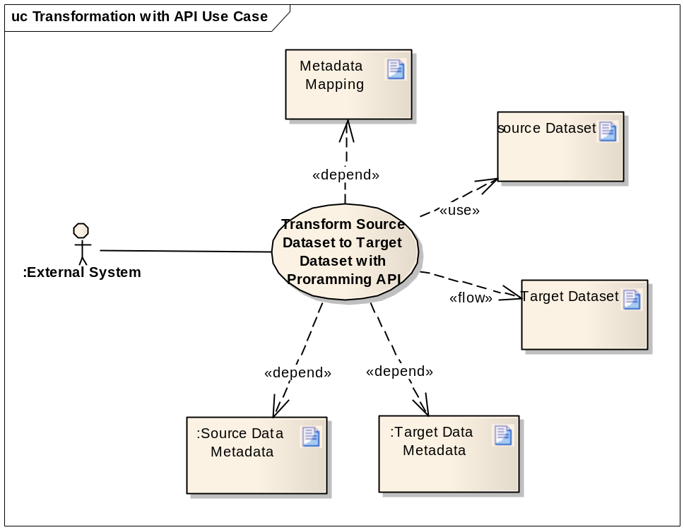

Brief Description
This use case covers the activities involved in integrating CMTS module with an external information processing system as plug-in. The external system accesses CMTS transformation engine though API and/or Web Service. The transformation engine transforms source dataset to target dataset using the predefined mapping along with associated source metadata and target metadata.

Primary Actor
External System

Secondary Actor
N/A

Preconditions
- Mapping between the source metadata and target metadata has been completed
- A valid mapping file was created

Basic Flow of Events
- User starts data transformation step
- User processes mapping file, source metadata file, target metadata file, and source dataset file
- User invokes CMTS transformation engine through API
- CMTS transformation engine processes mapping file along with associated source metadata and target metadata
- CMTS transformation engine generates target data using source data and mapping

Alternate Flow
N/A

Post Conditions
Success Conditions
- Successfully creates the target dataset compliant with the target metadata
Error Conditions
- Fail to process mapping or source dataset
- Fail to generate target dataset

Special Requirements
N/A

Use Integration Artifacts for Compatible Transformation Tools

Use Case Model
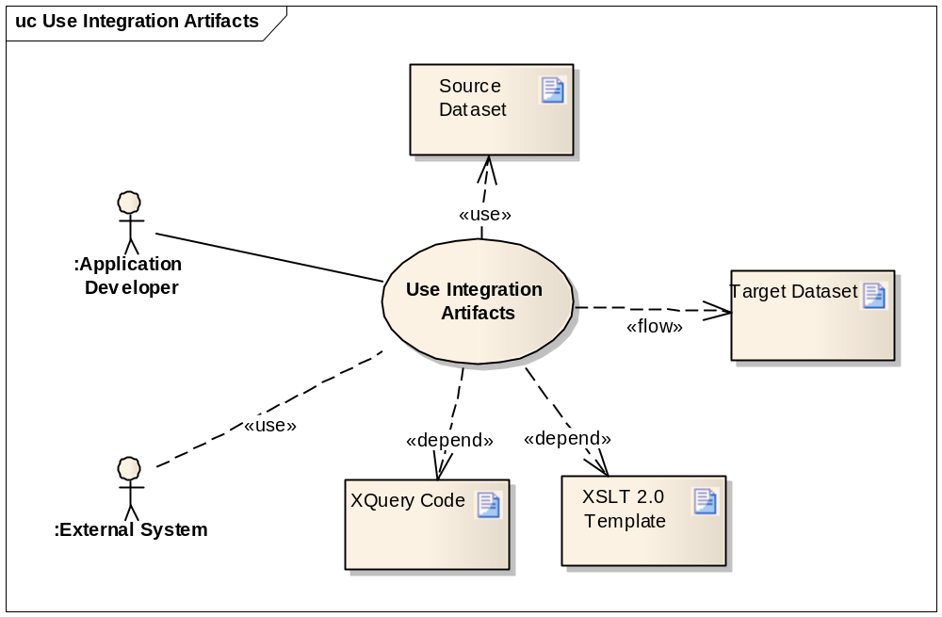

Brief Description
This use case covers the activities involved in transforming source dataset to target dataset using other compatible data transformation tools. The primary user develops an information processing system using CMTS to generate integration artifacts (in XQuery format or XSLST format) and available data transformation tools to create target dataset.
Alternatively, the second user may obtain the integration artifacts with other mapping tools and invoke the CMTS transformation API to convert source dataset to target dataset using the integration artifacts.

Primary Actor
Application Developer

Secondary Actor
External System

Preconditions
- The integration artifacts are generated in the format of XQuery if the transformation tools are compatible with XQuery.
- The integration artifacts are generated in the format of XSLT template if the transformation tools are compatible with XSLT.

Basic Flow of Events
- User generates integration artifacts following steps defined in use case 3.4: Generate Integration Artifacts for Compatible Transformation Tools.
- User implements integration program to access the transformation APIs of compatible tools.
- User forwards the integration artifacts generated in step 1 to the integration process.
- The compatible transformation tools generate target dataset using source dataset and integration artifacts.

Alternate Flow
At step 2, user can launch UI to invoke transformation functionalities if the transformation tools provide operation UI.

Post Conditions
Success Conditions
- The compatible transformation tools successfully generate target dataset from source dataset using the integration artifacts generated by CMTS.
Error Conditions
- The compatible tools fail in processing the integration artifacts generated by CMTS.

Special Requirements
N/A

Connect and Browse caDSR

Use Case Model
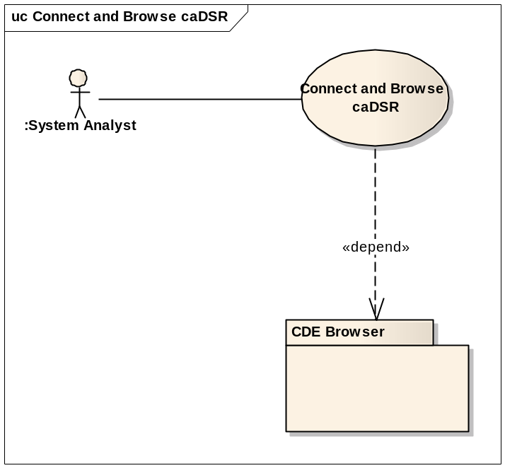

Brief Description
This use case covers the activities in exploring contents of caDSR by using CDE browser if metadata contain CDE semantic information.

Primary Actor
System Analyst

Secondary Actor
N/A

Preconditions
- caDSR has been setup.
- CDE browser has been deployed, which supports browser, searching, and exporting CDEs within or across contexts.

Basic Flow of Events
- User launches CMTS UI
- System display caDSR URL
- User open a source metadata file (XSD) or a target metadata file (XSD)
- User navigates the open metadata
- User selects a metadata node
- System display CDE information on property panel if the select node has CDE defined
- System display the CDE information linked to caDSR
- User clicks caDSR link
- System forward user’s request to caDSR site for CDE exploring and searching

Alternate Flow
At step 3, user may open an existing mapping, system presents the associated source metadata and target metadata

Post Conditions
Success Conditions
- User successfully explores caDSR from CMTS
Error Conditions
- If caDSR is not available, user is not allowed to explore caDSR from CMTS. But user is still able to perform other CMTS functionalities such as mapping, data transformation, etc.

Special Requirements
N/A

Access through Web Browser

Use Case Model
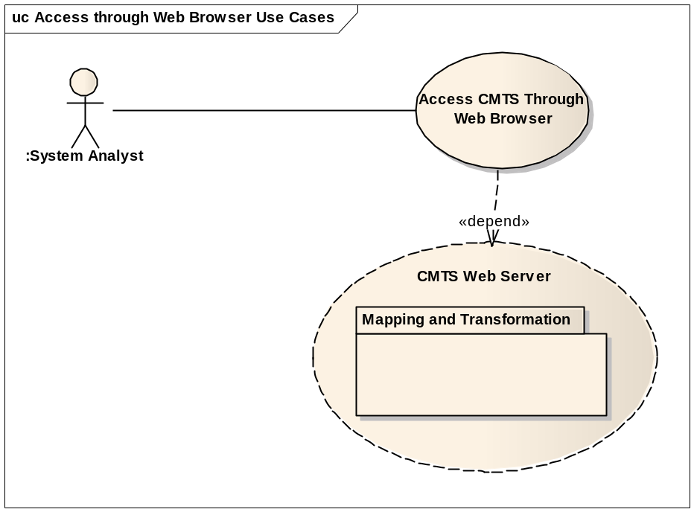

Brief Description
This use case covers the requirements to access the mapping and transformation functionalities through web browser such as Internet Explorer, FireFox, etc. The CMTS module implements web access API presenting its rich graphical features. Through web browser, user will be able to perform the full scope of operations in mapping and transformation.

Primary Actor
System Analyst

Secondary Actor
N/A

Preconditions
- The CMTS web server is deployed and ready to process client request.

Basic Flow of Events
- User launches web browser on client site
- The browser connects to CMTS site.
- CMTS web server delivers the application to client’s browser
- User creates mapping between a source metadata and a target metadata
- User performs other operations such as Generate Integration Artifacts for Compatible Transformation Tools, Transform Source Dataset to Target Dataset, etc.

Alternate Flow
At step 4, user can open an existing mapping, and then perform other operations.

Post Conditions
Success Conditions
- User successfully access CMTS web server and perform operations of mapping and transformation
Error Conditions
- Fail to access CMTS web server
- Fail to perform operations of mapping and transformation

Special Requirements
N/A

Overall Requirements
TBD

Requirements Prioritization
TBD
Priority | Use Case Name | Supp Requirement Ref #

Sign Off

Approval

Workspace General Contractor Rep Print Name Date
Architecture Workspace Rep Print Name Date
VCDE Workspace Rep Print Name Date
Workspace Working Group Rep Print Name Date
NCICB Rep Print Name Date

